CTF CHALLENGE WRITEUP
Romeo and Juliet
Miscellaneous | Easy | 84 Points

Challenge
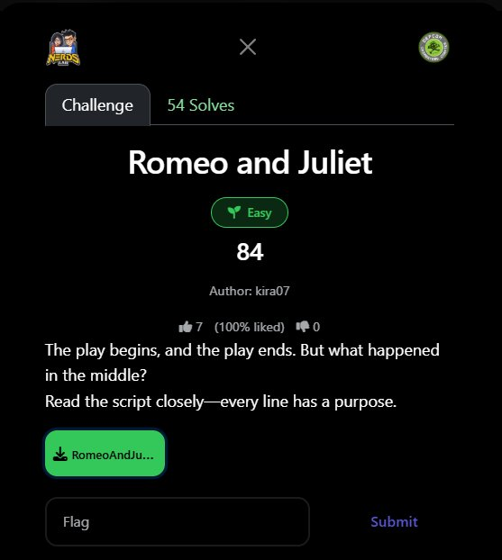
Figure 1: Challenge page on the CTF platform

Challenge Information
Challenge Name | Romeo and Juliet
Category | Miscellaneous
Difficulty | Easy
Points | 84
Author | kira07
Solves | 54
File | RomeoAndJuliet.txt — a play-format script
Description | "The play begins, and the play ends. But what happened in the middle? Read the script closely — every line has a purpose."
Flag | defcon{r34d_7h3_57463_d1r3c710n5}

Background: Shakespeare Programming Language (SPL)
This challenge is a custom implementation of the Shakespeare Programming Language (SPL) — a real esoteric programming language where programs are written as Shakespearean plays.

In SPL, characters in the play act as variables. Dialogue assigns values and performs operations on those variables. "Speak your mind!" outputs the current variable’s value as an ASCII character.

Value System: Adjectives as Binary Powers
The key insight is how values are encoded. Each adjective before a noun ("king") doubles the value. The noun itself = 1:

SPL Phrase | Adjective Count | Value (2^n) | ASCII char (example)
a king | 0 | 1 (2^0)
a noble king | 1 | 2 (2^1)
a fair noble king | 2 | 4 (2^2)
a bold fair noble king | 3 | 8 (2^3)
a brave bold fair noble king | 4 | 16 (2^4)
a sweet brave bold fair noble king | 5 | 32 (2^5)
a gentle sweet brave bold fair noble king | 6 | 64 (2^6)
a warm gentle sweet brave bold fair noble king | 7 | 128 (2^7)

Step 1: Identify the Language
Reading the script reveals structured patterns that look like code disguised as a play:

- Characters as variables: Romeo and Juliet are the two variables. When Juliet speaks "Thou art...", she is assigning a value to Romeo.
- Three operations only: "Thou art the difference between A and B" = A−B (absolute set), "sum of thyself and X" = add X, "difference between thyself and X" = subtract X.
- Output instruction: "Speak your mind!" → print chr(Romeo) — outputs the current value of Romeo as an ASCII character.
- Misdirection in Act I: Scene I says "Thou art a miserable vile cowardly foul evil pig!" — negative character insults are irrelevant noise. Only Scene II matters.

Step 2: Decode the Operation Syntax
Three statement patterns produce all the logic:

Statement | Meaning
Thou art the difference between a X and a Y. | Romeo = value(X) − value(Y) [absolute assignment]
Thou art the sum of thyself and a X. | Romeo += value(X)
Thou art the difference between thyself and a X. | Romeo −= value(X)
Speak your mind! | print(chr(Romeo))

Step 3: Execution Trace (First 12 Outputs)
Tracing through Scene II, counting adjectives to get values and applying operations:

Instruction | Operation | Romeo Value | Output
difference between warm(7adj) and sweet(5adj) | 128 − 32 | 96
sum of thyself and fair noble(2adj) | +4 | 100
Speak your mind! | — | 100 | 'd'
sum of thyself and a king(0adj) | +1 | 101
Speak your mind! | — | 101 | 'e'
sum of thyself and a king | +1 | 102
Speak your mind! | — | 102 | 'f'
difference between thyself and fair noble(2adj) | −4 | 98
sum of thyself and a king | +1 | 99
Speak your mind! | — | 99 | 'c'
sum of thyself and bold fair noble(3adj) | +8 | 107
sum of thyself and fair noble(2adj) | +4 | 111
Speak your mind! | — | 111 | 'o'
difference between thyself and a king | −1 | 110
Speak your mind! | — | 110 | 'n'
(... continues building '{r34d_7h3_57463_d1r3c710n5}')

Step 4: Automated Python Solver
Rather than tracing every line by hand, a short Python interpreter handles the full script:

import re

text = open('RomeoAndJuliet.txt').read()
lines = [l.strip() for l in text.split('\n') if l.strip()]

ADJECTIVES = ['warm','gentle','sweet','brave','bold','fair','noble']

def get_value(phrase):
count = sum(1 for w in phrase.lower().split() if w in ADJECTIVES)
return 2**count

romeo = 0
output = []
in_scene2 = False

for line in lines:
if 'Scene II' in line: in_scene2 = True; continue
if 'Scene III' in line: break
if not in_scene2: continue

# Absolute assignment: difference between A and B
m = re.match(r'Thou art the difference between a (.+) and a (.+)\.', line)
if m: romeo = get_value(m.group(1)) - get_value(m.group(2)); continue

# Add: sum of thyself and X
m = re.match(r'Thou art the sum of thyself and a (.+)\.', line)
if m: romeo += get_value(m.group(1)); continue

# Subtract: difference between thyself and X
m = re.match(r'Thou art the difference between thyself and a (.+)\.', line)
if m: romeo -= get_value(m.group(1)); continue

if line == 'Speak your mind!': output.append(chr(romeo))

print('defcon{' + ''.join(output).strip('defcon{}') + '}')
# defcon{r34d_7h3_57463_d1r3c710n5}

Flag Recovered
FLAG: defcon{r34d_7h3_57463_d1r3c710n5}

The flag in leet-speak: "read the stage directions" — a perfect meta-joke. The title “The Unread Stage Directions” is Scene II itself, and the entire flag is encoded as stage directions (Juliet’s dialogue instructions to Romeo).

Notable Misdirections
- Scene I (The False Dawn): Romeo says "Thou art a miserable vile cowardly foul evil pig!" — this insults Juliet but produces no output. It is pure misdirection to confuse solvers who try to decode it.
- Negative adjectives: "Miserable", "vile", "cowardly", "foul", "evil" are ALL negative adjectives in SPL. They negate the noun value. This line sets Juliet = −1, which is irrelevant since Juliet never speaks after this.
- Title text: "The Tragedy of the Unseen Path" and character descriptions are standard SPL boilerplate — they define the program structure, not operations.
- Scene loop: "Let us return to scene II" at the end of Scene I is a GOTO that skips Scene I entirely on re-entry — the program only processes Scene II once then exits at Scene III.

Lessons Learned
- Recognise esoteric languages: SPL is a well-known esoteric language. When you see a script formatted as a play with characters doing arithmetic dialogue, immediately look up SPL syntax.
- Every line has a purpose: The challenge description says exactly this. No line in the script is filler — every "Thou art" and "Speak your mind!" produces a specific ASCII character.
- Ignore the misdirection: Scene I is entirely misdirection. The real computation only happens in Scene II, which is titled "The Unread Stage Directions" — the flag tells you where to look.
- Automate the trace: Manual tracing through 100+ lines is error-prone. A 20-line Python regex parser handles the entire script in milliseconds.

DEFCON CTF — Romeo and Juliet — Solved

